SOFTWARE REQUIREMENTS SPECIFICATION (SRS)

University Archive & Management System

Table of Contents
- Introduction
- Overall Description
- System Features and Functional Requirements
- External Interface Requirements
- Non-Functional Requirements
- Database Requirements
- System Models
- System Architecture
- Testing Requirements
- Risk Analysis
- Future Enhancements
- Appendices
- Conclusion

1. Introduction

1.1 Purpose
The purpose of this Software Requirements Specification (SRS) document is to describe the functional and non-functional requirements of the University Archive & Management System. The system is designed to digitize, preserve, organize, and manage academic projects and records in a centralized web-based platform.

1.2 Scope
The University Archive & Management System is a secure web-based application that allows students, professors, and administrators to upload, review, archive, search, and manage academic projects efficiently.
The system aims to:
- Replace traditional paper-based archives
- Reduce project loss and data redundancy
- Improve accessibility of academic resources
- Enable secure project management
- Support long-term digital preservation

1.3 Intended Audience
This document is intended for:
- Software Developers
- Project Supervisors
- Database Designers
- System Administrators
- Testers
- University Authorities
- End Users (Students & Professors)

1.4 Definitions, Acronyms, and Abbreviations
Term | Meaning
SRS | Software Requirements Specification
UI | User Interface
DBMS | Database Management System
Admin | System Administrator
PHP | Hypertext Preprocessor
SQL | Structured Query Language
ERD | Entity Relationship Diagram
DFD | Data Flow Diagram

1.5 References
- IEEE SRS Documentation Standard
- PHP Official Documentation
- MySQL Documentation
- HTML, CSS, JavaScript Documentation

2. Overall Description

2.1 Product Perspective
The University Archive & Management System is an independent web application developed for universities to maintain academic projects digitally. The system integrates file management, metadata storage, user authentication, and archive searching.

2.2 Product Functions
Major system functionalities include:
- User Registration and Login
- Project Upload
- Project Approval System
- Search and Filter
- Department Management
- Report Generation
- Notification System
- Dashboard Analytics
- File Download and Viewing
- Activity Monitoring

2.3 User Classes and Characteristics

Admin
- Full system access
- Manage students and professors
- Generate reports
- Monitor activities

Professor
- Review submitted projects
- Approve or reject projects
- Monitor assigned student projects

Student
- Upload academic projects
- View project status
- Search previous projects

2.4 Operating Environment
Component | Specification
Operating System | Windows/Linux
Frontend | HTML, CSS, JavaScript
Backend | PHP
Database | MySQL
Server | Apache/XAMPP
Browser | Chrome, Firefox, Edge

2.5 Design and Implementation Constraints
- Requires internet connectivity
- File size limitations for uploads
- Role-based authentication required
- Must support secure database transactions

2.6 Assumptions and Dependencies
- Users have valid university credentials
- Server remains available continuously
- Proper backup system exists

3. System Features and Functional Requirements

3.1 Login System

Description
Users can securely log into the system using email and password.

Functional Requirements
- Validate user credentials
- Password encryption
- Session management
- Forgot password option

3.2 Project Upload Module

Description
Students upload project files with metadata.

Inputs
- Project Title
- Abstract
- Department
- Supervisor
- File Attachment

Outputs
- Upload confirmation
- Pending review status

3.3 Project Approval Module

Description
Professors and administrators review uploaded projects.

Functional Requirements
- Approve projects
- Reject projects
- Request modifications
- Track approval status

3.4 Search and Filter Module

Description
Users search archived projects using filters.

Search Filters
- Department
- Year
- Keywords

3.5 Dashboard Module

Description
Displays statistics and system information.

Features
- Total projects
- Total users
- Upload history
- Approval statistics

3.6 Notification Module

Description
Sends notifications regarding project updates.

Notification Types
- Upload confirmation
- Approval status
- Review requests

3.7 Report Generation Module

Description
Admins can generate academic and activity reports.

Output Formats
- PDF
- Printable reports

4. External Interface Requirements

4.1 User Interface Requirements
- Responsive web interface
- Easy navigation
- Dashboard visualization
- Accessible forms

4.2 Hardware Interface Requirements
- Server storage system
- Backup storage devices

4.3 Software Interface Requirements
- MySQL Database
- Apache Server
- Browser compatibility

4.4 Communication Interface Requirements
- HTTP/HTTPS protocol
- Secure authentication
- Network data transfer

5. Non-Functional Requirements

5.1 Performance Requirements
- Response time below 3 seconds
- Support multiple concurrent users

5.2 Security Requirements
- Role-based access control
- Data encryption
- Secure file upload validation
- SQL injection prevention

5.3 Reliability Requirements
- Automatic backup system
- Error recovery support
- Transaction rollback

5.4 Availability Requirements
- 24/7 system availability
- Cloud/server uptime support

5.5 Scalability Requirements
The system should support:
- Multiple departments
- Thousands of archived projects
- Future mobile application integration

5.6 Maintainability Requirements
- Modular coding structure
- Easy bug fixing
- Future feature extension

5.7 Portability Requirements
The application should run on:
- Windows
- Linux
- Modern web browsers

6. Database Requirements

6.1 Database Design
Main database tables:
- Students
- Professors
- Projects
- Departments
- Approvals
- Tags

6.2 Data Dictionary

Students Table
Field | Type | Description
student_id | INT | Primary Key
name | VARCHAR | Student Name
email | VARCHAR | Email Address
department_id | INT | Department ID

Projects Table
Field | Type | Description
project_id | INT | Primary Key
title | VARCHAR | Project Title
abstract | TEXT | Project Description
file_path | VARCHAR | File Location
status | VARCHAR | Approval Status

7. System Models

7.1 Use Case Diagram
Actors:
- Admin
- Professor
- Student
Main Use Cases:
- Login
- Upload Project
- Approve Project
- Search Archive
- Generate Reports

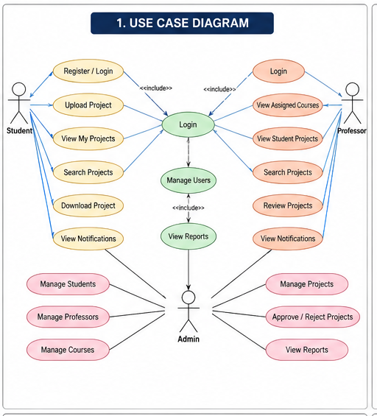

7.2 Sequence Diagram
- Login Process
- Project Upload Process
- Review and Approval Process
- Search and Retrieval Process

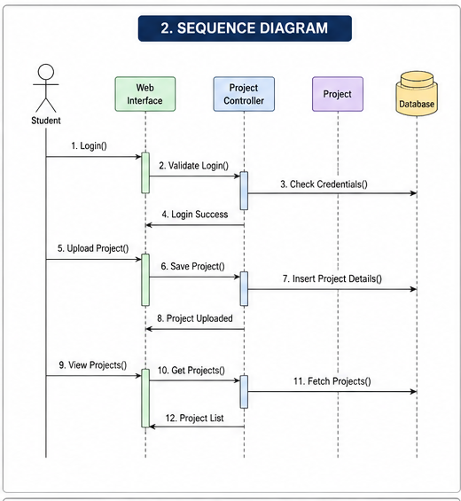

7.3Class Diagram
- User
- Student
- Professor
- Admin
- Project
- Project Review
- Notification
- Course

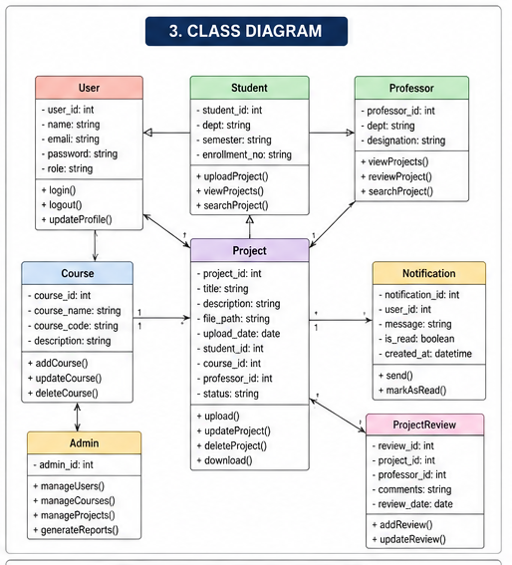

7.4 Activity Diagram
- User Login
- Upload Project
- Project Review & Approval
- Search and Download Archive
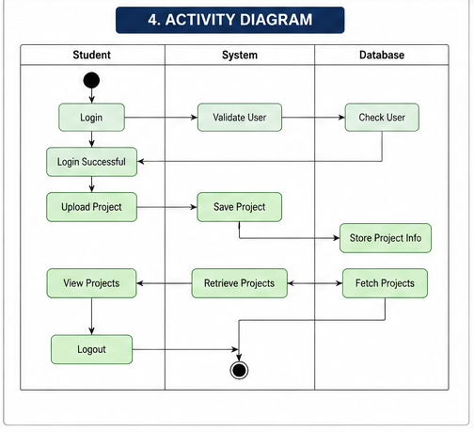

7.5 Data Flow Diagram (DFD)
Processes:
- User Authentication
- Project Submission
- Approval Workflow
- Archive Searching
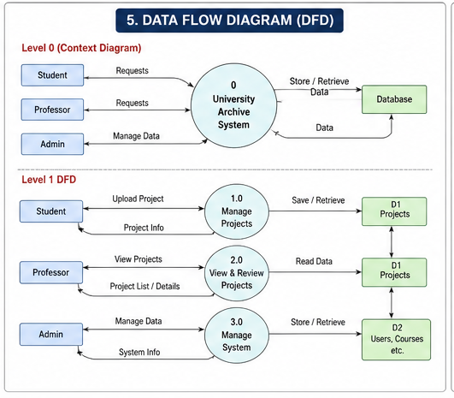

8. System Architecture

Architecture Type
Client-Server Architecture

Components
- Frontend Layer
- Backend Layer
- Database Layer
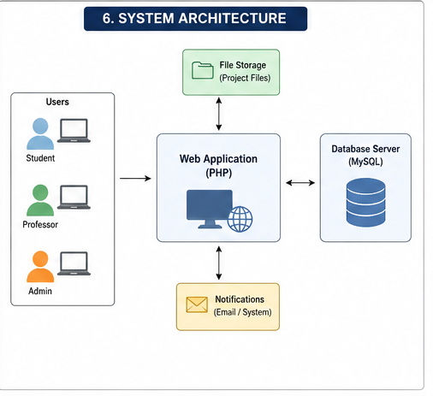

9. Testing Requirements

9.1 Unit Testing
Test individual modules separately.

9.2 Integration Testing
Test communication between modules.

9.3 System Testing
Test complete application workflow.

9.4 User Acceptance Testing
Validate system using real users.

10. Risk Analysis
Risk | Mitigation
Database Failure | Daily backup
Unauthorized Access | Authentication system
File Corruption | Secure storage
Server Downtime | Recovery mechanism

11. Future Enhancements
Future improvements include:
- AI-powered semantic search
- Mobile application
- Email and push notifications
- Cloud deployment
- Machine learning recommendations

12. Appendices

Appendix A – Technologies Used
- PHP
- MySQL
- HTML
- CSS
- JavaScript

Appendix B – Workflow Summary
- User Login
- Project Upload
- Professor Review
- Approval Process
- Archive Storage

13. Conclusion
The University Archive & Management System provides a secure, efficient, and scalable solution for preserving and managing academic projects digitally. The system minimizes paper-based management issues, improves accessibility, and enhances institutional knowledge preservation through centralized archival technology.
The platform supports students, professors, and administrators through role-based access, project review workflows, advanced searching, and secure document management.

